Program 1

Aim:
Implement Stack using linked list

Program code

#include<stdio.h>
#include<stdlib.h>
struct node
{
int data;
struct node *link;
}
*top=NULL;

int isEmpty()
{
if(top==NULL)
return 1;
else
return 0;
}
void push(int data)
{
struct node *newNode =(struct node*) malloc(sizeof( struct node));
if(newNode==NULL)
{
printf("Stack is overflow");

}
else
{
newNode->data=data;
newNode->link=NULL;
newNode->link=top;
top=newNode;
}
}

int pop()
{
struct node *temp;
int val;
if(isEmpty())
{
printf("Stack underflow\n");

}
else
{
temp=top;
val=temp->data;
top=temp->link;
free(temp);
temp=NULL;
printf("Deleted element is : %d",val);
}
}

int peek()
{
if(isEmpty())
{
printf("Stack underflow");
exit(1);
}
return top->data;
}

void search(int value)
{
struct node *temp;
temp=top;
int found;

if(isEmpty())
{
printf("Stack underflow");

}
else
{

while(temp)
{
if(temp->data==value)
{
found=1;
break;
}
temp=temp->link;
}
if(found==1)
{
printf("The element is inside stack\n");
}
else
{
printf("The element is not inside stack");

}

}

}

void print()
{
struct node *temp;
temp=top;
if(isEmpty())
{
printf("Stack underflow");
exit(1);
}

printf("The stack elements are:\n");
while(temp)
{
printf("%d\n",temp->data);
temp=temp->link;

}

}

int main()
{
int choice,data,value;
while(1)
{
printf("\n1.Push\n");
printf("2.Pop\n");
printf("3.Print the top element\n");
printf("4.Print all the elements of stack\n");
printf("5.Search\n");
printf("6.Quit\n");
printf("please enter your choice");
scanf("%d",&choice);
switch(choice)

{
case 1:
printf("enter the element to be pushed");
scanf("%d",&data);
push(data);
break;
case 2:
pop();

break;
case 3:
printf("The top most element of the stack is %d\n",peek());
break;
case 4:
print();
break;
case 5:
printf("Enter value to be search");
scanf("%d",&value);
search(value);
break;
case 6:
exit(1);
default:
printf("Wrong choice\n");
}
}
return 0;
}

Ouput:

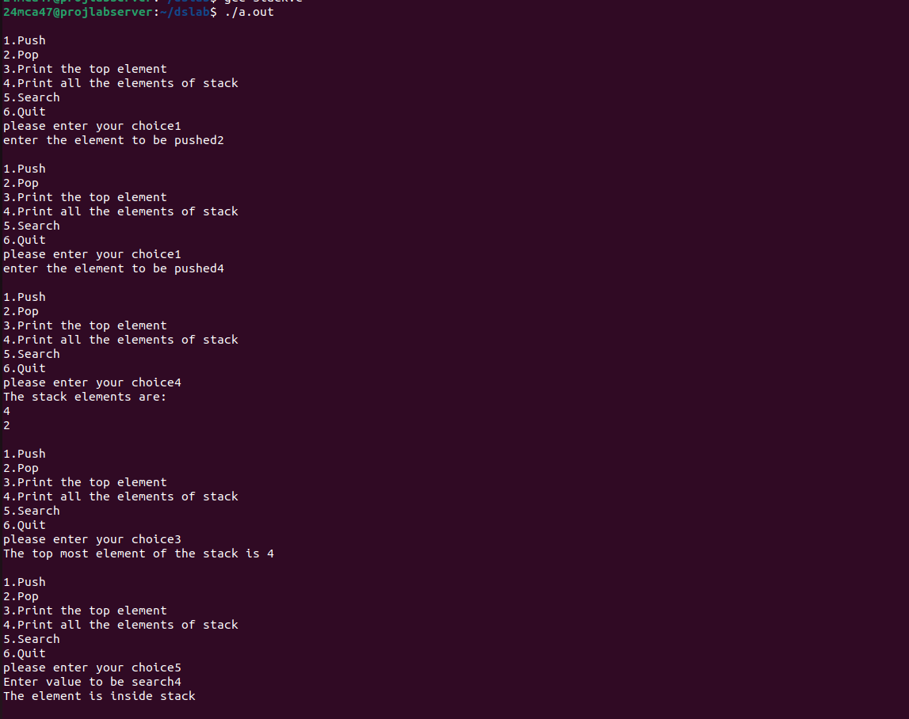

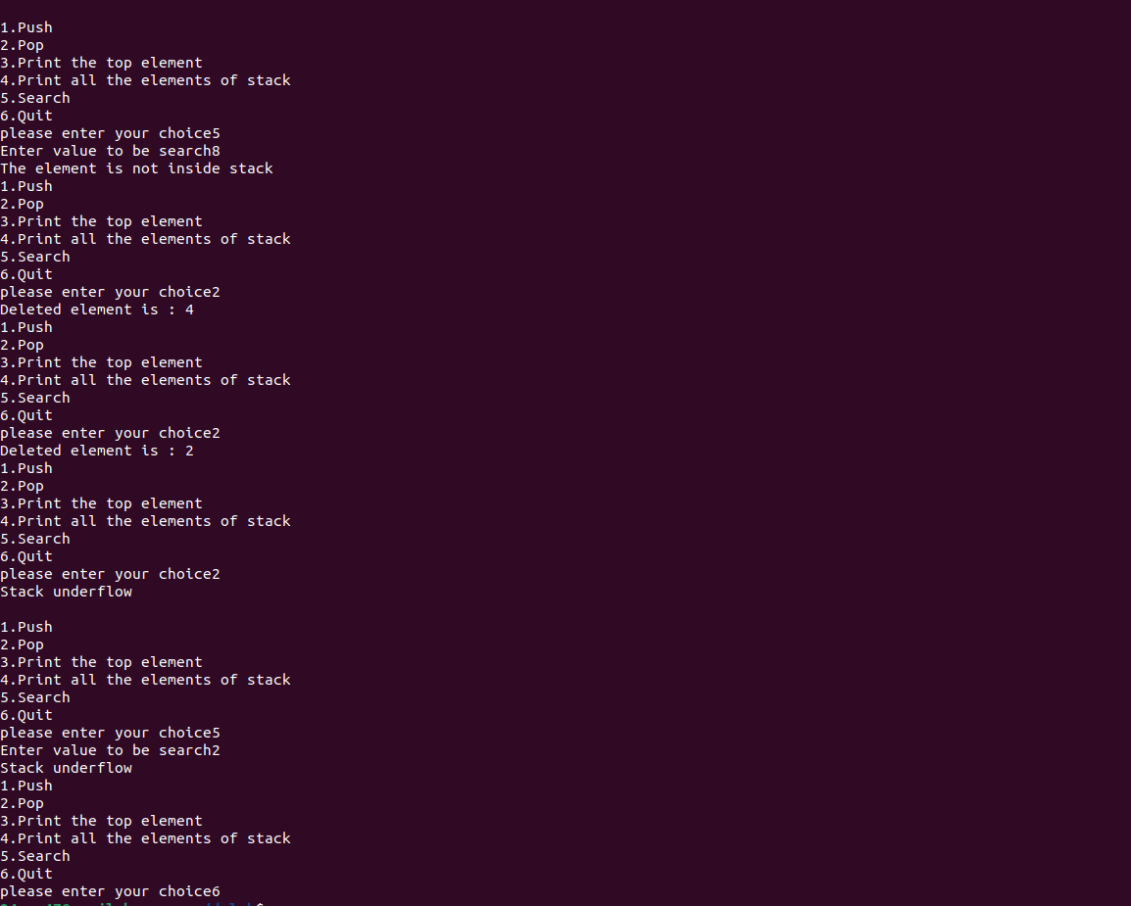

PROGRAM-2

Aim:
Implement singly linked list

program code:

#include<stdio.h>
#include<stdlib.h>

struct node
{
int data;
struct node *next;
};
struct node *head=NULL;

struct node *createNode(int data)
{
struct node *newNode=(struct node*)malloc(sizeof(struct node));
newNode->data=data;
newNode->next=NULL;
return newNode;
}

void insertAtBeginning(int data)
{
struct node *newNode=createNode(data);
newNode->next=head;
head=newNode;
}

void insertAtEnd(int data)
{
struct node *newNode=createNode(data);
if(head==NULL)
{
head=newNode;
return;
}
struct node *temp=head;
while(temp->next!=NULL)
{
temp=temp->next;
}
temp->next=newNode;
}

void insertAtAnyPosition(int data,int position)
{
if(position<1)
{
printf("Enter position greater than 1\n");
return;
}

if(position==1)
{
insertAtBeginning(data);
return;
}
struct node *newNode=createNode(data);
struct node *temp=head;
for(int i=1;i<position-1 && temp!=NULL;i++)
{
temp=temp->next;
}
if(temp==NULL)
{
printf("Position out of bounds\n");
free(newNode);

}
else
{
newNode->next=temp->next;
temp->next=newNode;
}
}

void deleteAtBeginning()
{
if(head==NULL)
{
printf("List is empty\n");
return;
}
struct node *temp=head;
head=head->next;
free(temp);
}

void deleteAtEnd()
{
if(head==NULL)
{
printf("List is empty\n");
return;
}
struct node *temp=head;
struct node *prev=NULL;
if(head->next==NULL)
{
free(temp);
head=NULL;
}
else
{
while(temp->next!=NULL)
{
prev=temp;
temp=temp->next;
}
prev->next=NULL;
free(temp);

}
}

void deleteAtAnyPosition(int position)
{
if(head==NULL)
{
printf("List is empty\n");
return;
}
if(position<1)
{
printf("Position must be greater than zero\n");
return;
}
if(position==1)
{
deleteAtBeginning();
return;
}
struct node *temp=head;
struct node *prev=NULL;
for(int i=1;i<position && temp!=NULL;i++)
{
prev=temp;
temp=temp->next;
}
if(temp==NULL)
{
printf("Position out of bound");
}
else
{
prev->next=temp->next;
free(temp);
}

}

void display()
{
struct node *temp=head;
if(temp==NULL)
{
printf("List is Empty\n");
return;
}
while(temp!=NULL)
{
printf("%d\t",temp->data);
temp=temp->next;
}
}

void search(int value)
{
struct node *temp=head;
int found,position=1;
if(temp==NULL)
{
printf("List is Empty\n");
return;
}
while(temp!=NULL)
{
if(temp->data==value)
{
found=1;
break;
}
temp=temp->next;
position++;
}
if(found==1)
{
printf("Data found at %d\n",position);
}
else
{
printf("Value not found in list\n");
}
}

int main()
{
int choice,data,value,position;
do
{
printf("\nSelect your choice\n");
printf("1.Insert At Beginning List\n");
printf("2.Insert At End of List\n");
printf("3.Insert At Any Position of List\n");
printf("4.Delete At Beginning of List\n");
printf("5.Delete At End of List\n");
printf("6.Delete At Any Position of List\n");
printf("7.Display List\n");
printf("8.Search an element in list\n");
printf("9.Exit\n");
printf("Enter Your choice\n");
scanf("%d",&choice);
switch(choice)
{
case 1:
printf("Enter data to be inserted\n");
scanf("%d",&data);
insertAtBeginning(data);
break;

case 2:
printf("Enter data to be inserted\n");
scanf("%d",&data);
insertAtEnd(data);
break;

case 3:
printf("Enter data to be inserted\n");
scanf("%d",&data);
printf("Enter Position to be insert data\n");
scanf("%d",&position);
insertAtAnyPosition(data,position);
break;

case 4:
deleteAtBeginning();
break;

case 5:
deleteAtEnd();
break;

case 6:
printf("Enter Position to be delete data\n");
scanf("%d",&position);
deleteAtAnyPosition(position);
break;

case 7:
display();
break;

case 8:
printf("Enter value to be searched\n");
scanf("%d",&value);
search(value);
break;

case 9:
printf("Exiting");
exit(0);
break;

default:
printf("Wrong choice");
break;
}
}

while(choice!=9);
return 0;
}

Output:

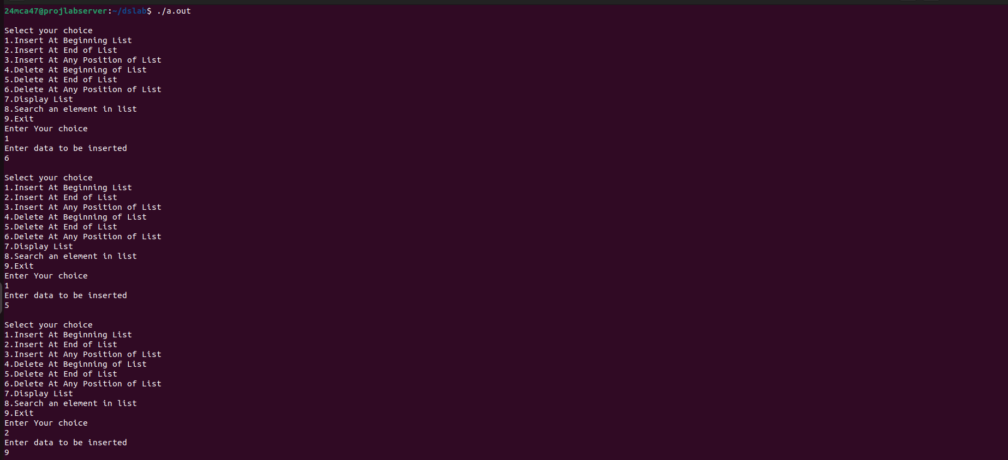

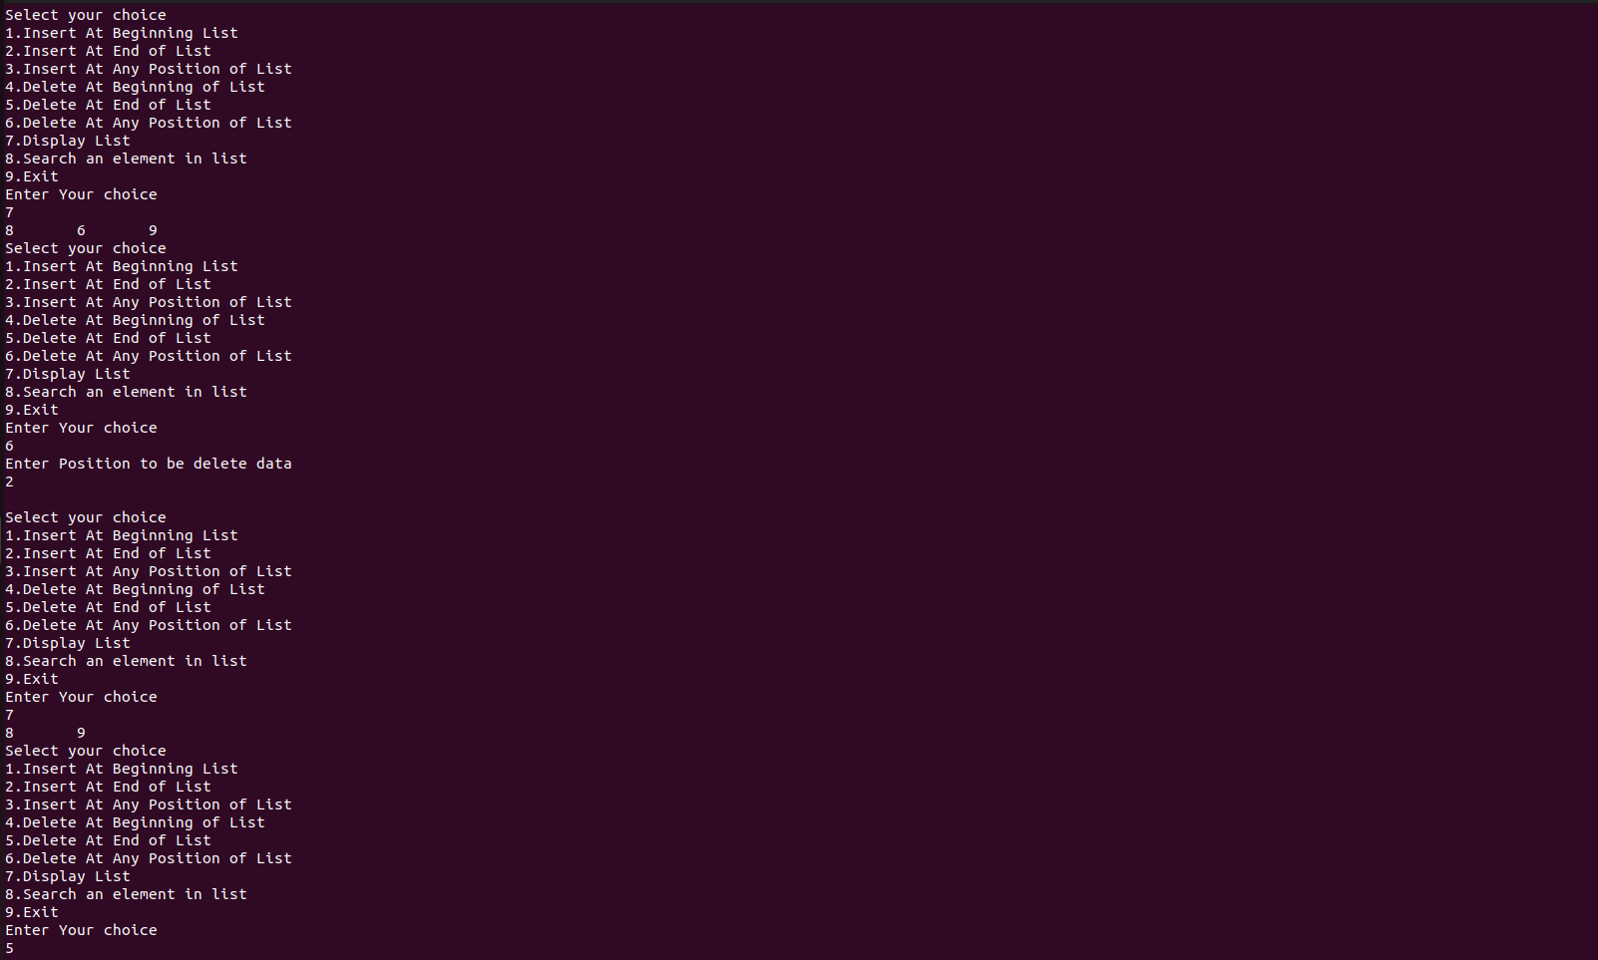
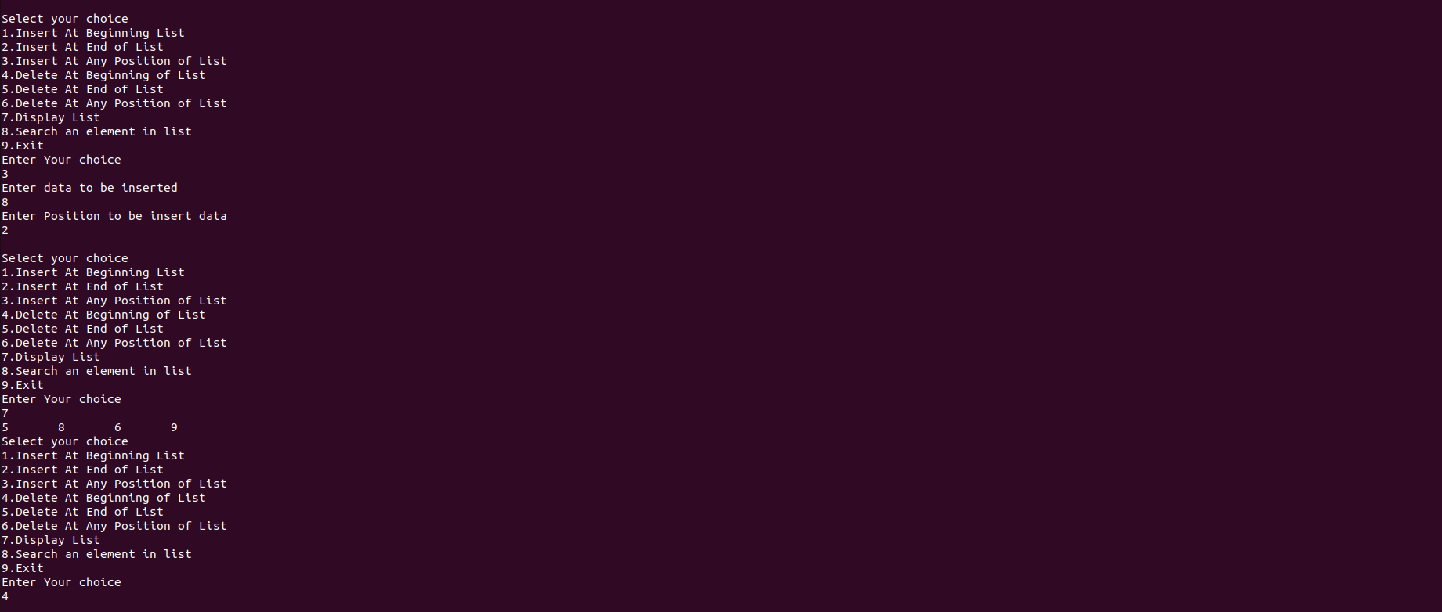

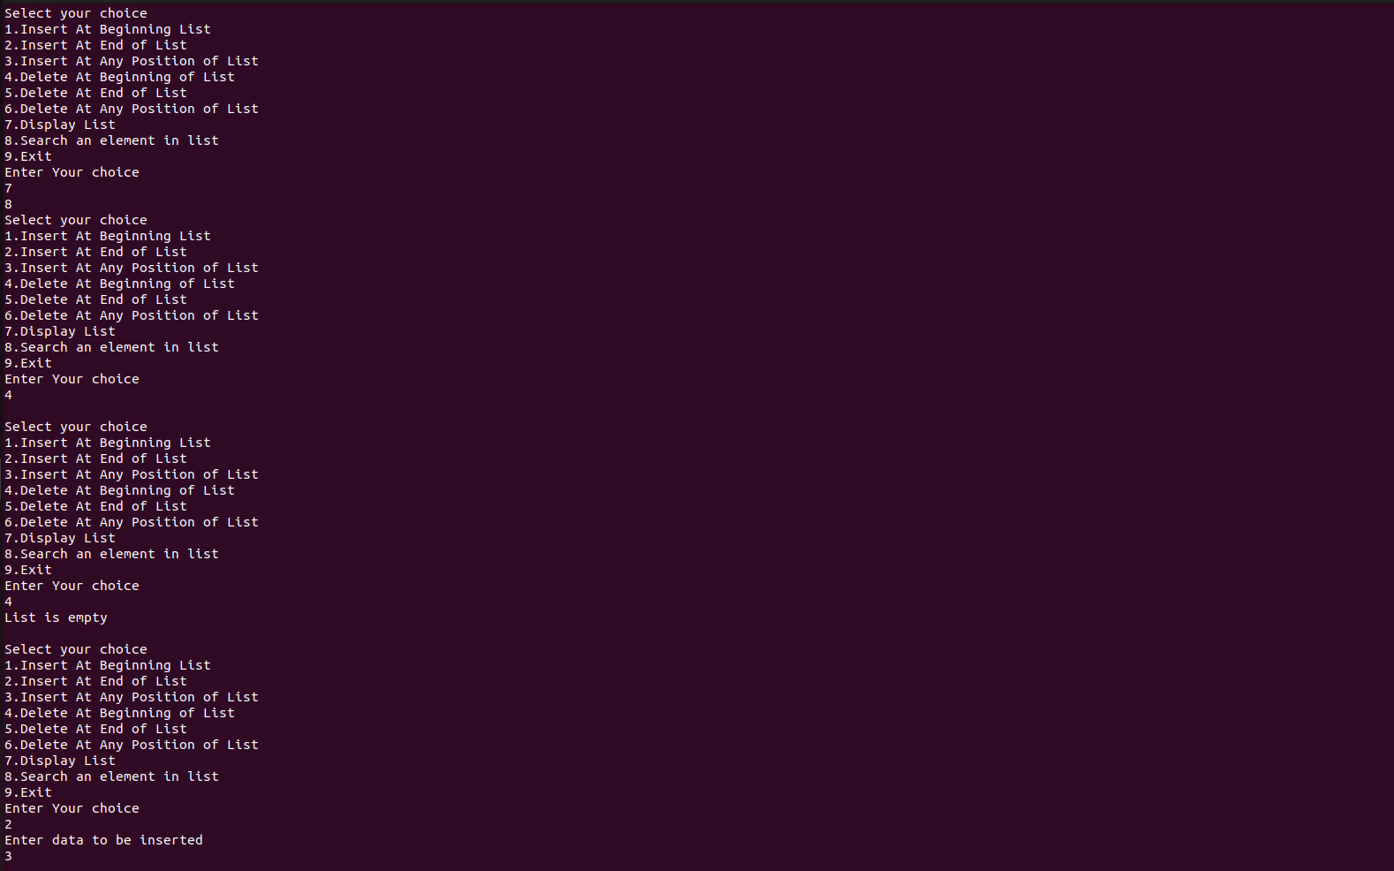

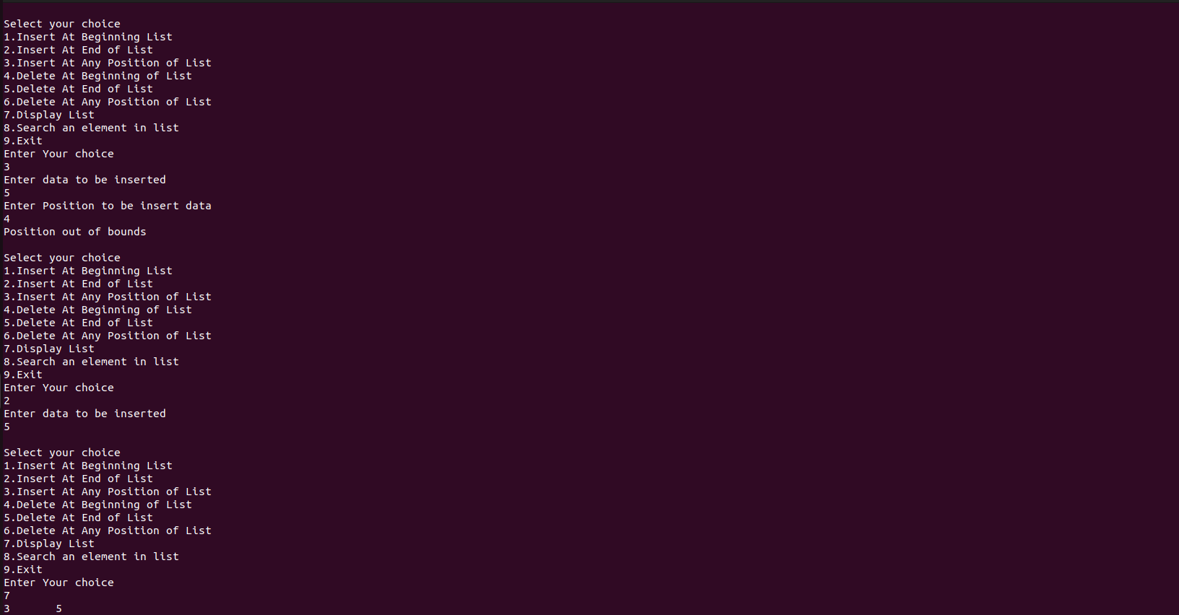

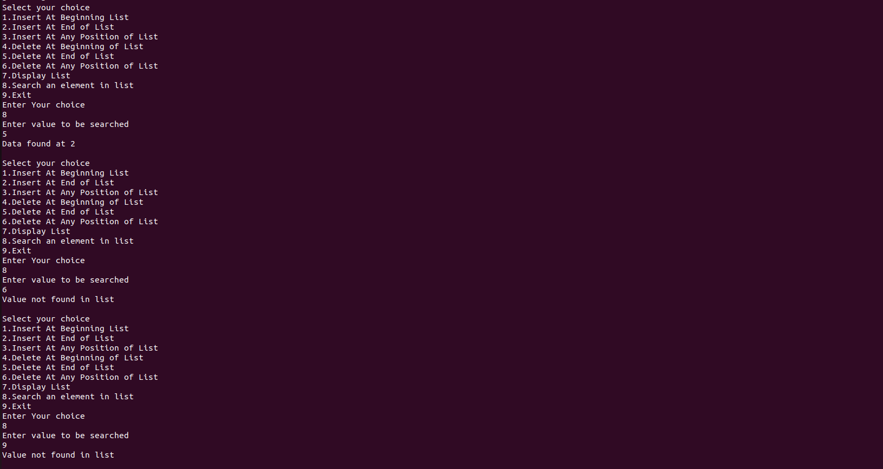

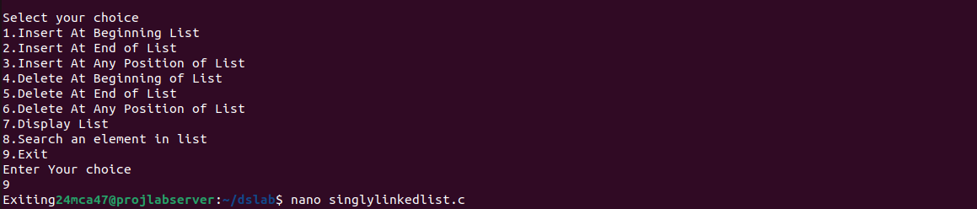

Program 3

Aim:
Implement Doubly linked list

Program code

#include<stdio.h>
#include<stdlib.h>
struct Node{
struct Node* prev;
int data;
struct Node* next;
};
struct Node* head=NULL;
struct Node* createNode(int data)
{
struct Node* newNode=(struct Node*)malloc(sizeof(struct Node));
newNode->prev=NULL;
newNode->data=data;
newNode->next=NULL;
return newNode;
}

void insertAtBeginning(int data)
{
struct Node *newNode=createNode(data);
newNode->prev=NULL;
newNode->next=head;
head=newNode;
}

void insertAtEnd(int data)
{
struct Node *newNode=createNode(data);
if(head==NULL)
{
head=newNode;
return;
}
struct Node *temp=head;
while(temp->next!=NULL)
{
temp=temp->next;
}
temp->next=newNode;
newNode->prev=temp;
newNode->next=NULL;
}

void insertAtAnyPosition(int data,int position)
{
if(position<1)
{
printf("Enter position greater than 1\n");
return;
}

if(position==1)
{
insertAtBeginning(data);
return;
}
struct Node *newNode=createNode(data);
struct Node *temp=head;
for(int i=1;i<position-1 && temp!=NULL;i++)
{
temp=temp->next;
}
if(temp==NULL)
{
printf("Position out of bounds\n");
free(newNode);

}
else
{
newNode->next=temp->next;
temp->next->prev=newNode;
temp->next=newNode;
newNode->prev=temp;
}

}
void deleteAtBeginning()
{
if(head==NULL)
{
printf("List is empty\n");
return;
}
struct Node *temp=head;
head=temp->next;
if(head!=NULL)
{
head->prev=NULL;
}
free(temp);
printf("Item Deleted from List\n");
}

void deleteAtEnd()
{
if(head==NULL)
{
printf("List is empty\n");
return;
}
struct Node *temp=head;
struct Node *loc=NULL;
if(head->next==NULL)
{
free(temp);
head=NULL;
}
else
{
while(temp->next!=NULL)
{
loc=temp;
temp=temp->next;
}
loc->next=NULL;
free(temp);
printf("Item Deleted from List\n");

}

}

void deleteAtAnyposition(int position)
{
if(head==NULL)
{
printf("List is empty\n");
return;
}
if(position<1)
{
printf("Position must be greater than zero\n");
return;
}
if(position==1)
{
deleteAtBeginning();
return;
}
struct Node *temp=head;
struct Node *loc=NULL;
for(int i=1;i<position && temp!=NULL;i++)
{
loc=temp;
temp=temp->next;
}
if(temp==NULL)
{
printf("Position out of bound");
}
else
{
loc->next=temp->next;
loc->prev=temp->prev;
free(temp);
printf("Item Deleted from List\n");
}

}

void display()
{
struct Node *temp=head;
if(temp==NULL)
{
printf("List is Empty\n");
return;
}
while(temp!=NULL)
{
printf("%d\t",temp->data);
temp=temp->next;
}
}

void search(int value)
{
struct Node *temp=head;
int found,position=1;
if(temp==NULL)
{
printf("List is Empty\n");
return;
}
while(temp!=NULL)
{
if(temp->data==value)
{
found=1;
break;
}
temp=temp->next;
position++;
}
if(found==1)
{
printf("Data found at %d\n",position);
}
else
{
printf("Value not found in list\n");
}
}
int main()
{
int data,position,choice,value;
do
{
printf("\nDoubly Linked List Operations:\n");
printf("Select your choice\n");
printf("1.Insert At Beginning\n");
printf("2.Insert At End\n");
printf("3.Insert At Any Position\n");
printf("4.Delete At Beginning\n");
printf("5.Delete At End\n");
printf("6.Delete At Any Position\n");
printf("7.Display List\n");
printf("8.Search\n");
printf("9.Exit\n");
printf("Enter Your Choice:");
scanf("%d",&choice);
switch(choice)
{
case 1:
printf("Enter the data to be entered:\n");
scanf("%d",&data);
insertAtBeginning(data);
break;
case 2:
printf("Enter the data to be entered:\n");
scanf("%d",&data);
insertAtEnd(data);
break;
case 3:
printf("Enter the data to be entered:\n");
scanf("%d",&data);
printf("Enter the position to be entered:\n");
scanf("%d",&position);

insertAtAnyPosition(data,position);
break;
case 4:
deleteAtBeginning();
break;
case 5:
deleteAtEnd();
break;
case 6:
printf("Enter position to be deleted\n");
scanf("%d",&position);
deleteAtAnyposition(position);
case 7:
display();
break;
case 8:
printf("Enter value to be searched\n");
scanf("%d",&value);
search(value);
break;
case 9:
printf("Exiting");
exit(0);
break;
default:
printf("Enter proper choice\n");
break;

}
}
while(choice!=9);
return 0;

}

Output:

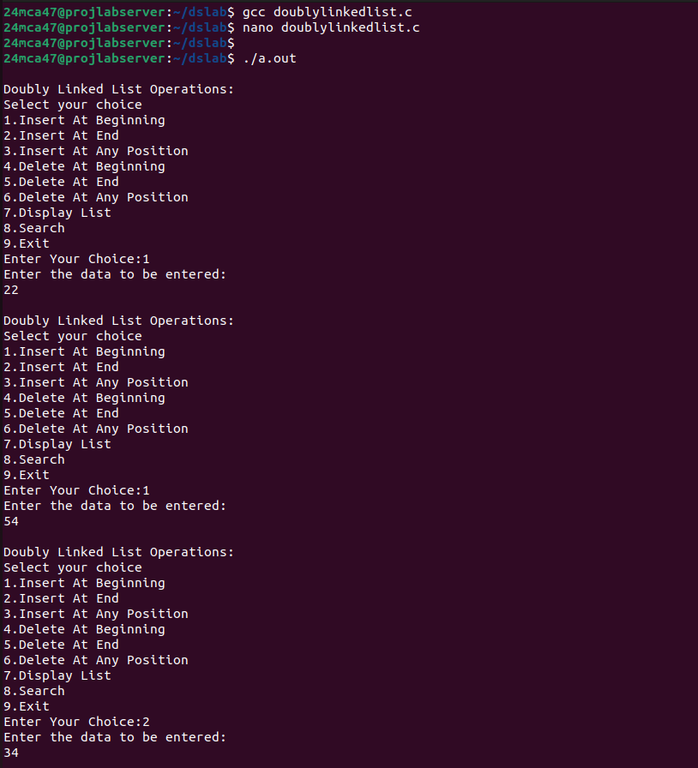

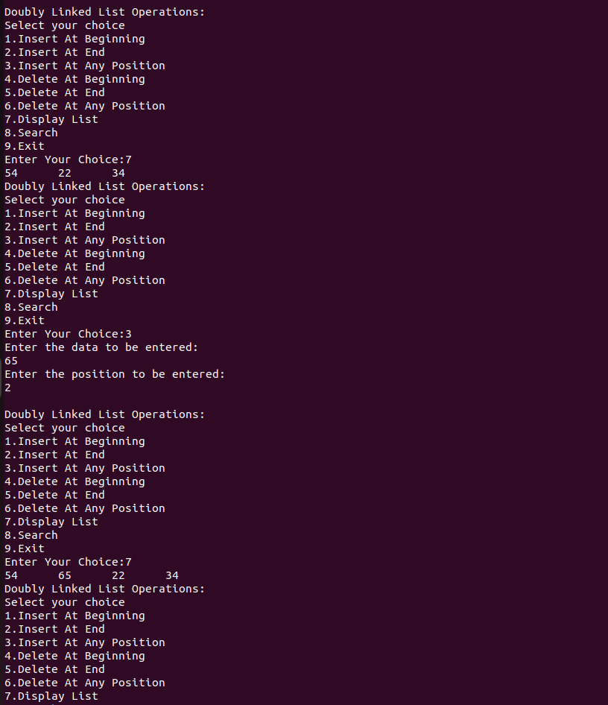

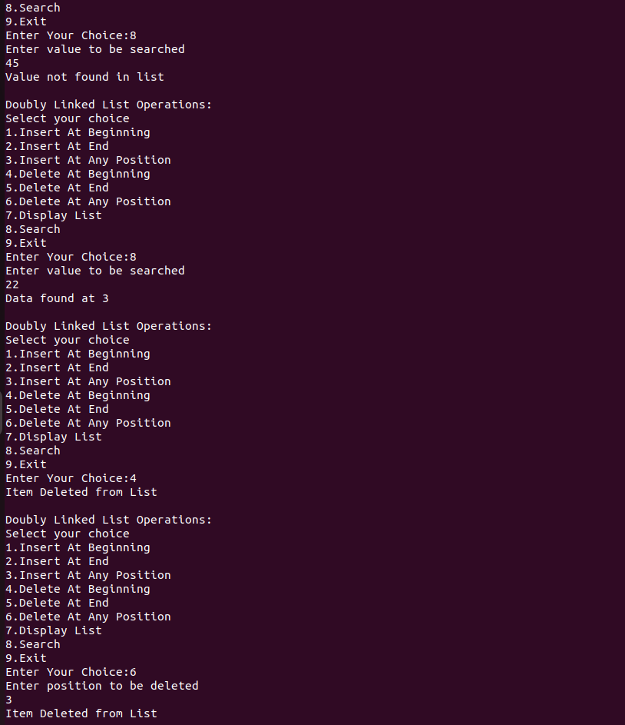

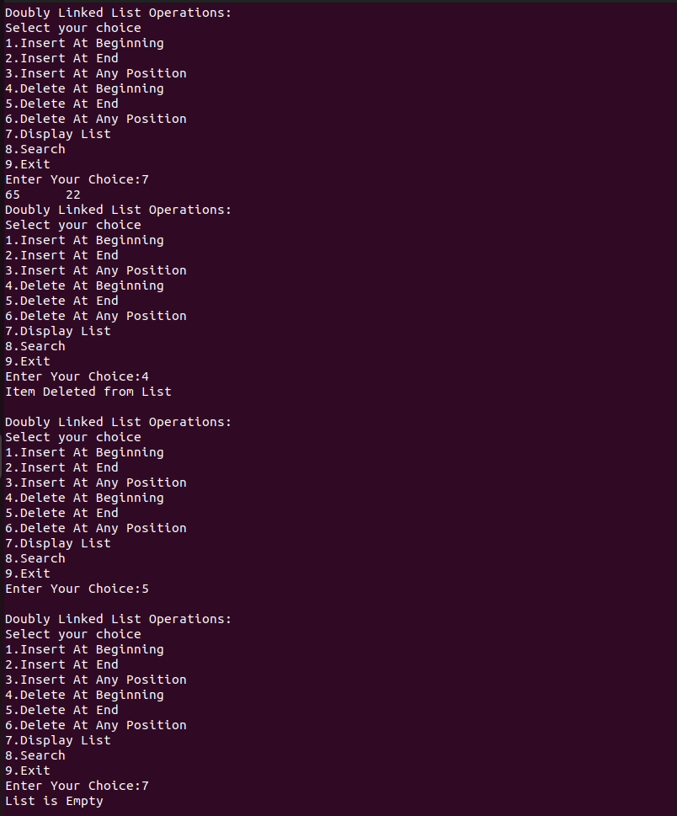

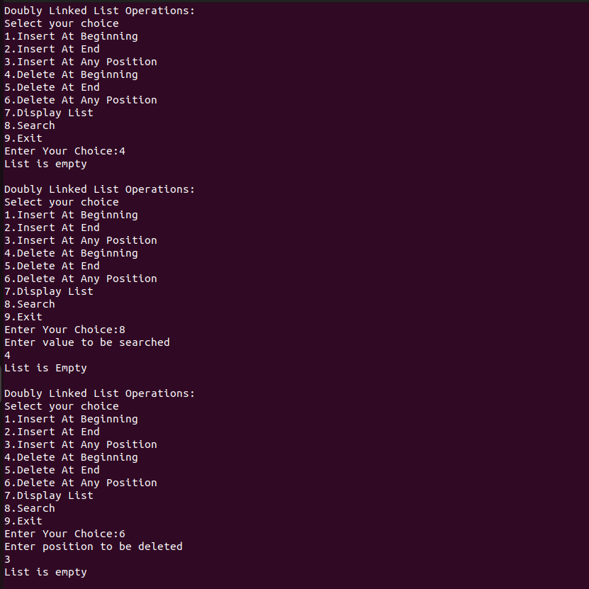

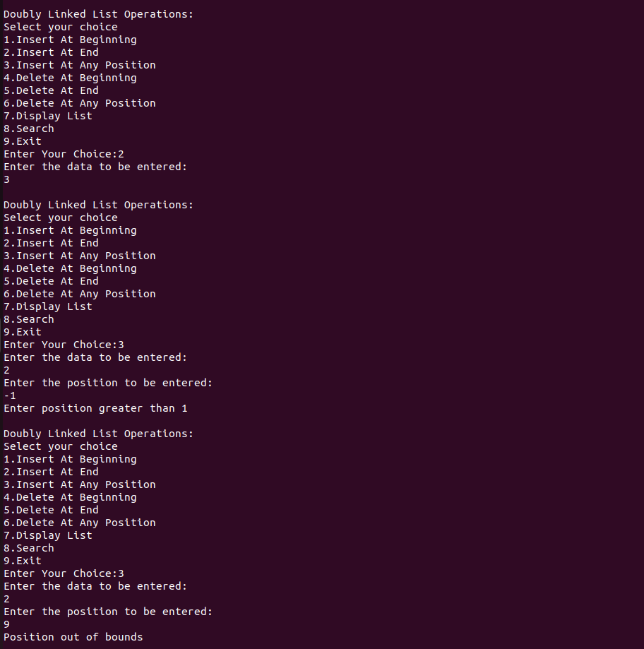

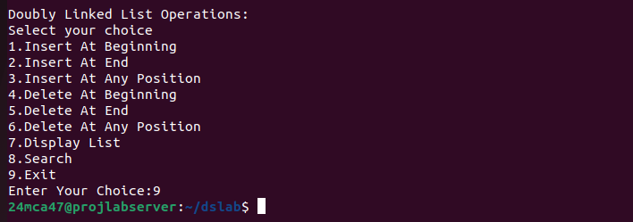

Program 4

Aim:
Implement Binary Search Tree

Program code:

#include<stdio.h>
#include<stdlib.h>
struct node{
int data;
struct node *left;
struct node *right;

};

struct node* createnode(int data)
{
struct node* newNode=(struct node*)malloc(sizeof(struct node));
newNode->data=data;
newNode->left=NULL;
newNode->right=NULL;
return newNode;
}

struct node* insert(struct node* root,int data)
{
if(root==NULL)
{
root=createnode(data);

}
else if(data<root->data)
{
root->left=insert(root->left,data);
}
else if(data>root->data)
{
root->right=insert(root->right,data);
}
return root;

}

struct node* findMin(struct node *root)
{
while(root && root->left!=NULL)
{
root=root->left;
}
return root;
}
struct node* deleteNode(struct node* root,int data)
{
if(root==NULL)
{
printf("The value to be deleted is not present inside tree\n");
return root;
}
if(data<root->data)
{
root->left=deleteNode(root->left,data);

}
else if(data>root->data)
{
root->right=deleteNode(root->right,data);
}
else{
if(root->left==NULL)
{
struct node* temp=root->right;
free(root);
return temp;
}
else if(root->right==NULL)
{
struct node* temp=root->left;
free(root);
return temp;
}
struct node *temp=findMin(root->right);
root->data=temp->data;
root->right=deleteNode(root->right,temp->data);
}
return root;
}

struct node* search(struct node* root,int data)
{
if(root==NULL || root->data==data)
{
return root;
}
if(data<root->data)
{
return search(root->left,data);
}
else{
return search(root->right,data);
}
}

void preorder(struct node *root)
{
if(root!=NULL)
{
printf("%d->",root->data);
preorder(root->left);
preorder(root->right);
}
}

void inorder(struct node *root)
{
if(root!=NULL)
{
inorder(root->left);
printf("%d->",root->data);
inorder(root->right);
}
}

void postorder(struct node *root)
{
if(root!=NULL)
{

postorder(root->left);
postorder(root->right);
printf("%d->",root->data);
}
}

int main()
{
struct node* root=NULL;
int choice,value;
struct node* foundNode;
while(1)
{
printf("\nBinary Tree Operations:\n");
printf("Select your choice:\n");
printf("1.Insert \n");
printf("2.Delete\n");
printf("3.Search Tree\n");
printf("4.Preorder Traversal\n");
printf("5.Inorder Traversal\n");
printf("6.Postorder Traversal\n");
printf("7.Exit\n");
printf("Enter Your choice:\n");
scanf("%d",&choice);
switch(choice)
{
case 1:
printf("Enter Data to be entered\n");
scanf("%d",&value);
root=insert(root,value);
break;
case 2:
if(root==NULL)
{
printf("Tree is empty");
}
else
{
printf("Enter Data to be Deleted\n");
scanf("%d",&value);
root=deleteNode(root,value);
}
break;

case 3:
if(root==NULL)
{
printf("Tree is empty");
}
else
{

printf("Enter value to be searched\n");
scanf("%d",&value);
foundNode=search(root,value);
if(foundNode!=NULL)
{
printf("Value %d found in the tree.\n",value);
}
else
{
printf("Value %d not found in the tree.\n",value);

}
}
break;
case 4:
if(root==NULL)
{
printf("Tree is empty");
}
else
{
printf("Preorder Traversal:");
preorder(root);
printf("\n");
}
break;case 5:
if(root==NULL)
{
printf("Tree is empty");
}
else
{
printf("Inorder Traversal:");
inorder(root);
printf("\n");
}
break;

case 6:
if(root==NULL)
{
printf("Tree is empty");
}
else
{
printf("PostOrder Traversal:");
postorder(root);
printf("\n");
}
break;

case 7:
printf("Exiting");
exit(0);
break;
default:
printf("Invalid choice Try Again..\n");
break;

}
}

return 0;
}

Output:

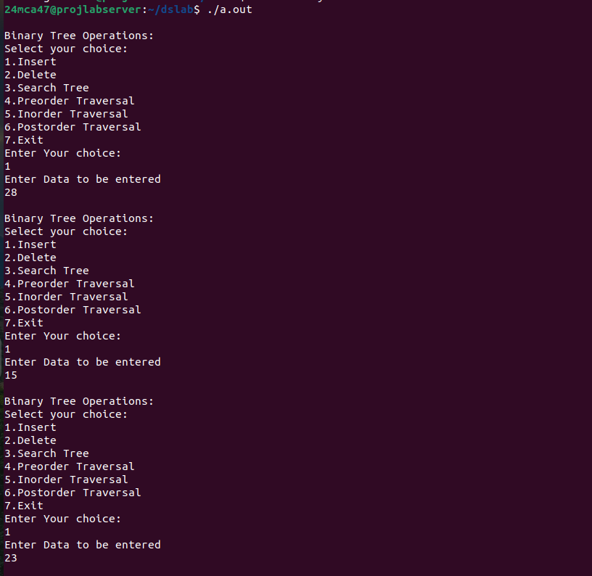

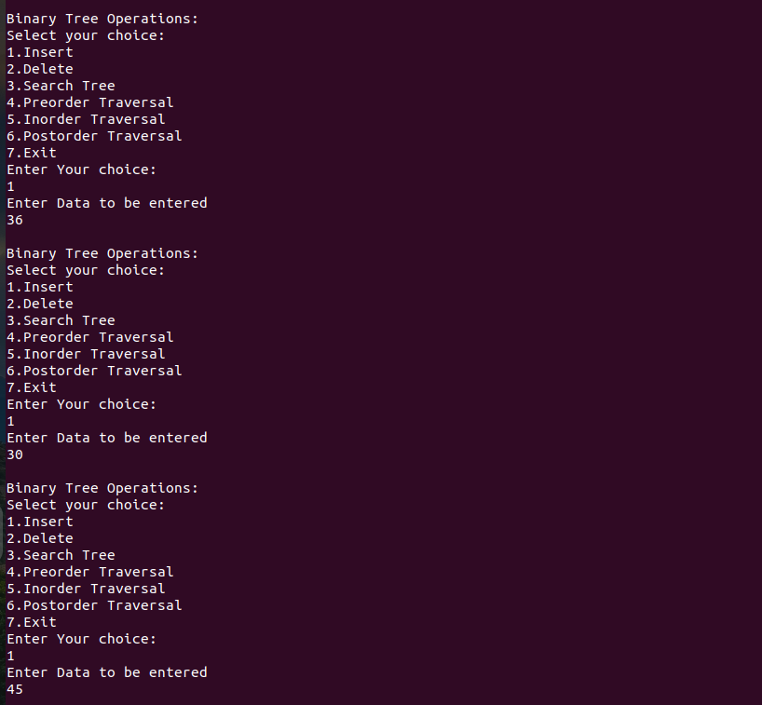

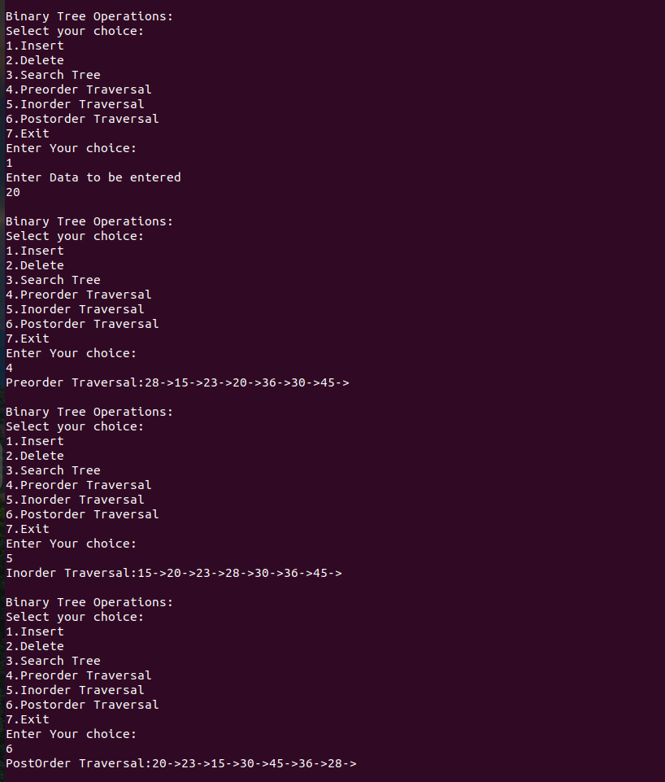

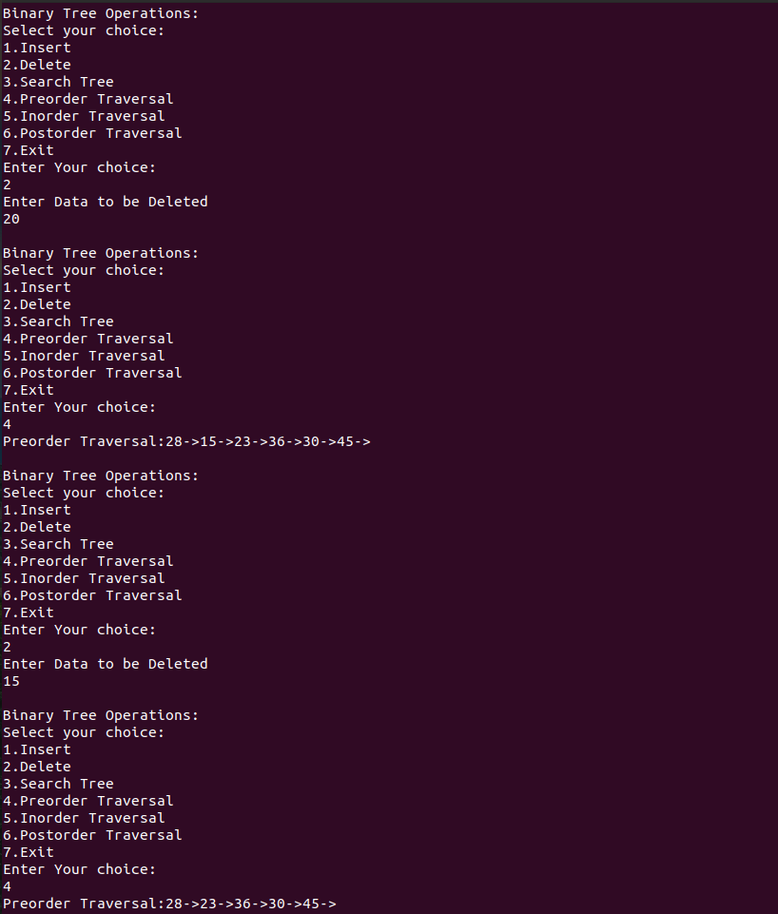

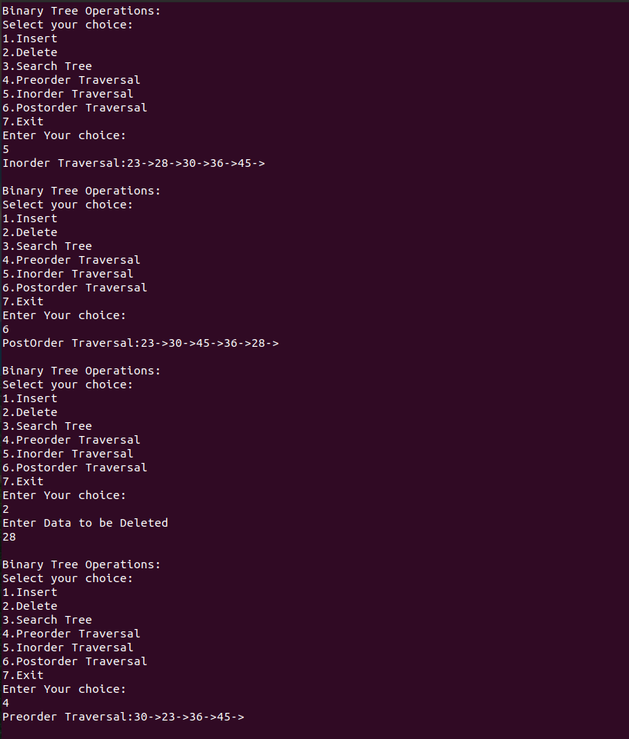

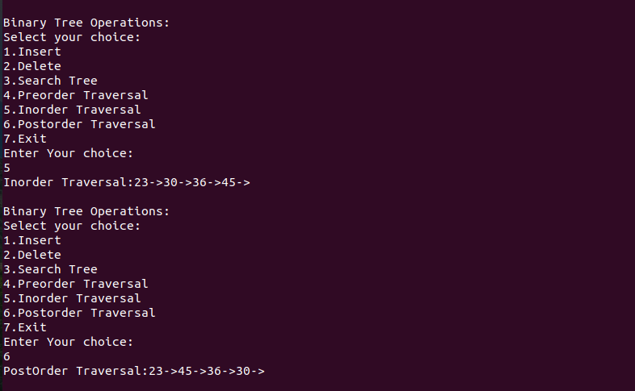

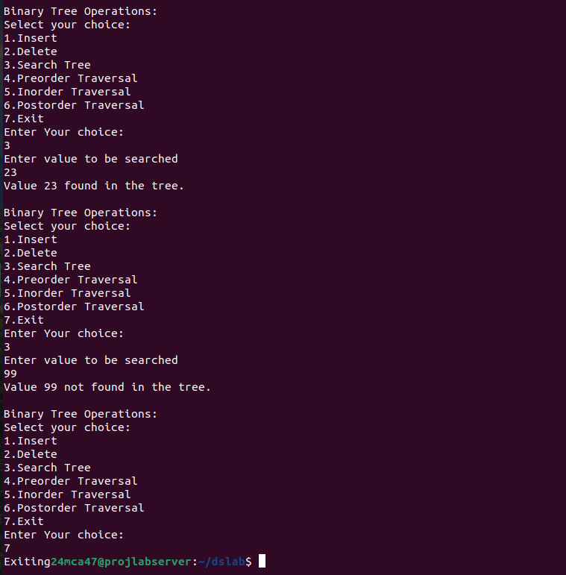

Program 5

Aim:
Implement Circular Queue using Array

Program code:

#include<stdio.h>
#include<stdlib.h>

int front=-1,rear=-1,size,*queue,item,i;

int enqueue()
{
if(front==-1 && rear==-1)
{
front=0;
rear=0;
printf("Enter element to be inserted:\n");
scanf("%d",&item);
queue[front]=item;

}

else if(((rear+1)%size)==front)
{
printf("\nQueue is ful\n");
}
else
{
printf("Enter element to be inserted:\n");
scanf("%d",&item);
rear=(rear+1)%size;
queue[rear]=item;

}

}

int dequeue()
{
if(front==-1 && rear==-1)
{
printf("Queue is Empty\n");
}
else if(front==rear)
{
printf("Deleted element is %d",queue[front]);
front=rear=-1;
}
else
{
printf("Deleted element is %d",queue[front]);
front=(front+1)%size;
}
}
int display()
{
if(front==-1 && rear==-1)
{
printf("\n Nothing to display");

}
else
{
printf("\nelements are:\t");
for(i=front;i!=rear;i=(i+1)%size)
{
printf("%d\t",queue[i]);
}
printf("%d\t",queue[i]);
}
}

int search()
{
if(front==-1 && rear==-1)
{
printf("\n Queue is Empty");

}
else
{
int searchItem,found=0;
printf("\nEnter element to be searched:");
scanf("%d",&searchItem);
for(i=front;i!=rear;i=(i+1)%size)
{
if(queue[i]==searchItem)
{
found=1;
break;
}

}
if(queue[i]==searchItem)
{
found=1;
}
if(found)
{
printf("Element %d found in Queue\n",searchItem);
}
else
{
printf("Element %d not found in Queue\n",searchItem);
}
}
}
int main()
{

int choice;
printf("Enter the size of circular Queue\n");
scanf("%d",&size);
queue=(int*)malloc(size * sizeof(int));
if(queue==NULL)
{
printf("\nMemory Allocation Failed,Exiting Program\n");
exit(1);
}
while(1)
{
printf("\nCircular Queue Operation\n");
printf("1.Enqueue\n");
printf("2.Dequeue\n");
printf("3.Search\n");
printf("4.Display\n");
printf("5.Exit\n");
printf("Enter your choice:\n");
scanf("%d",&choice);
switch(choice)
{
case 1:
enqueue();
break;

case 2:
dequeue();
break;

case 3:
search();
break;
case 4:
display();
break;
case 5:
free(queue);
exit(0);
break;
default:
printf("Please enter valid choice\n");
break;

}
}
}

Output:

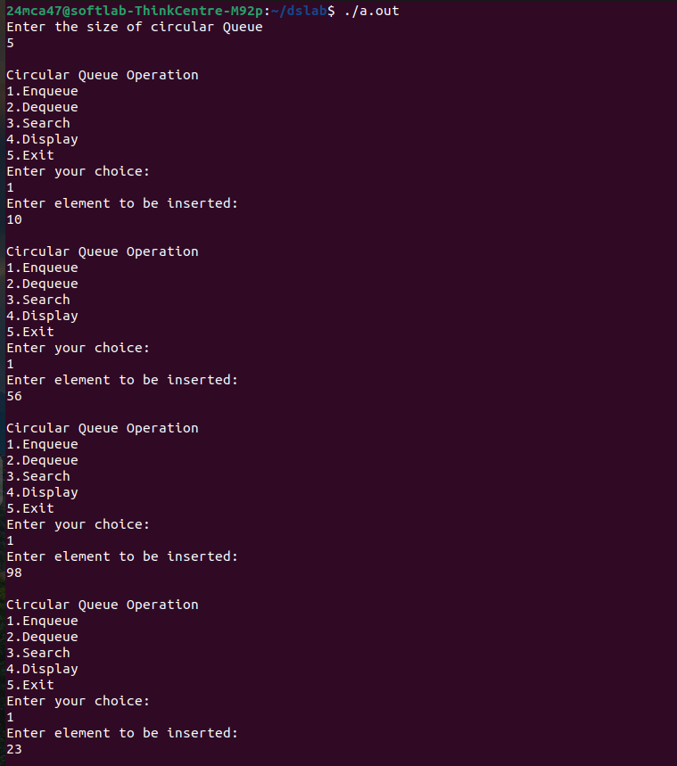

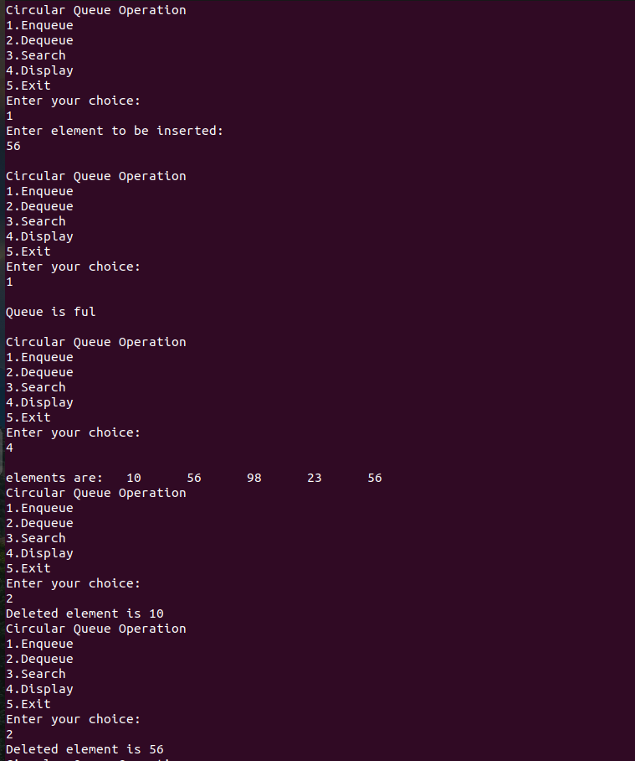

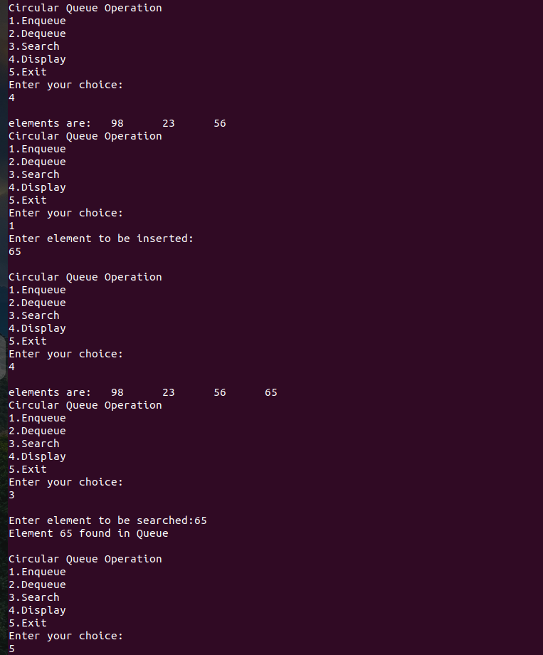

Program 6

Aim:
Implementation of bitstring using array

Program code:

#include <stdio.h>
#include <stdlib.h>
#define MAX_SIZE 20
int superSet[MAX_SIZE], superSetSize = 0;
int setA[MAX_SIZE], setASize = 0;
int setB[MAX_SIZE], setBSize = 0;
int bitStringA[MAX_SIZE], bitStringB[MAX_SIZE];
void getUniversalSet();
void getSet(int arr[], int *size);
int checkSetInUniversal(int arr[], int size);
void generateBitStrings();
void setUnion();
void setIntersection();
void setDifferenceAminusB();
void setDifferenceBminusA();
void printBitString(int arr[], int size);
void printSetFromBitString(int arr[], int size);

void getUniversalSet()
{
printf("Enter Universal Set Size (max %d): ", MAX_SIZE);
scanf("%d", &superSetSize);
if (superSetSize > MAX_SIZE)
{
printf("Error: Size exceeds maximum limit.\n");
exit(1);
}
printf("Enter %d elements for the Universal Set:\n", superSetSize);
for (int i = 0; i < superSetSize; i++)
{
printf("Element %d: ", i + 1);
scanf("%d", &superSet[i]);
}
}

void getSet(int arr[], int *size)
{
printf("Enter %d elements (must be in the Universal Set):\n", *size);
for (int i = 0; i < *size; i++)
{
printf("Element %d: ", i + 1);
scanf("%d", &arr[i]);
}
}

int checkSetInUniversal(int arr[], int size)
{
for (int i = 0; i < size; i++)
{
int found = 0;
for (int j = 0; j < superSetSize; j++)
{
if (arr[i] == superSet[j])
{
found = 1;
break;
}
}
if (!found)
{
printf("Error: Element %d is not in the Universal Set. Please enter the set again.\n", arr[i]);
return 0;
}
}
return 1;
}

void generateBitStrings()
{
for (int i = 0; i < superSetSize; i++)
{
bitStringA[i] = 0;
bitStringB[i] = 0;
}
for (int i = 0; i < setASize; i++)
{
for (int j = 0; j < superSetSize; j++)
{
if (setA[i] == superSet[j])
{
bitStringA[j] = 1;
break;
}
}
}
for (int i = 0; i < setBSize; i++)
{
for (int j = 0; j < superSetSize; j++)
{
if (setB[i] == superSet[j])
{
bitStringB[j] = 1;
break;
}
}
}
printf("Set A Bit String: ");
printBitString(bitStringA, superSetSize);
printf("Set B Bit String: ");
printBitString(bitStringB, superSetSize);
}

void setUnion()
{
int bitStringUnion[MAX_SIZE];
for (int i = 0; i < superSetSize; i++)
{
bitStringUnion[i] = bitStringA[i] | bitStringB[i];
}
printf("Union: ");
printBitString(bitStringUnion, superSetSize);
printf("Union Result (Values): ");
printSetFromBitString(bitStringUnion, superSetSize);
}
void setIntersection()
{
int bitStringIntersection[MAX_SIZE];
for (int i = 0; i < superSetSize; i++)
{
bitStringIntersection[i] = bitStringA[i] & bitStringB[i];
}
printf("Intersection: ");
printBitString(bitStringIntersection, superSetSize);
printf("Intersection Result (Values): ");
printSetFromBitString(bitStringIntersection, superSetSize);
}

void setDifferenceAminusB()
{
int bitStringDifferenceAminusB[MAX_SIZE];
for (int i = 0; i < superSetSize; i++)
{
bitStringDifferenceAminusB[i] = bitStringA[i] & (1 - bitStringB[i]);
}
printf("Difference (A - B): ");
printBitString(bitStringDifferenceAminusB, superSetSize);
printf("Difference Result (A - B, Values): ");
printSetFromBitString(bitStringDifferenceAminusB, superSetSize);
}

void setDifferenceBminusA()
{
int bitStringDifferenceBminusA[MAX_SIZE];
for (int i = 0; i < superSetSize; i++)
{
bitStringDifferenceBminusA[i] = bitStringB[i] & (1 - bitStringA[i]);
}
printf("Difference (B - A): ");
printBitString(bitStringDifferenceBminusA, superSetSize);
printf("Difference Result (B - A, Values): ");
printSetFromBitString(bitStringDifferenceBminusA, superSetSize);
}

void printBitString(int arr[], int size)
{
printf("{");
for (int i = 0; i < size; i++)
{
printf("%d", arr[i]);
if (i < size - 1)
{
printf(", ");
}
}
printf("}\n");
}

void printSetFromBitString(int arr[], int size)
{
int first = 1;
printf("{");
for (int i = 0; i < size; i++)
{
if (arr[i] == 1)
{
if (!first)
{
printf(", ");
}
printf("%d", superSet[i]);
first = 0;
}
}
printf("}\n");
}

int main()
{
int choice;
getUniversalSet();
do
{
printf("Enter Set A Size (max %d): ", superSetSize);
scanf("%d", &setASize);
if (setASize > superSetSize)
{
printf("Error: Set A size cannot exceed Universal Set size.\n");
}
}
while (setASize > superSetSize);
do
{
getSet(setA, &setASize);
}
while (checkSetInUniversal(setA, setASize) == 0);
do
{
printf("Enter Set B Size (max %d): ", superSetSize);
scanf("%d", &setBSize);
if (setBSize > superSetSize)
{
printf("Error: Set B size cannot exceed Universal Set size.\n");
}
}
while (setBSize > superSetSize);
do
{
getSet(setB, &setBSize);
}
while (checkSetInUniversal(setB, setBSize) == 0);
generateBitStrings();
do
{
printf("\nChoose an operation:\n");
printf("1. Union of A and B\n");
printf("2. Intersection of A and B\n");
printf("3. Difference (A - B)\n");
printf("4. Difference (B - A)\n");
printf("5. Exit\n");
printf("Enter your choice: ");
scanf("%d", &choice);
switch (choice)
{
case 1:
setUnion();
break;
case 2:
setIntersection();
break;
case 3:
setDifferenceAminusB();
break;
case 4:
setDifferenceBminusA();
break;
case 5:
printf("Exiting program.\n");
break;
default:
printf("Invalid choice. Please try again.\n");
}
}
while (choice != 5);
return 0;
}

Output:

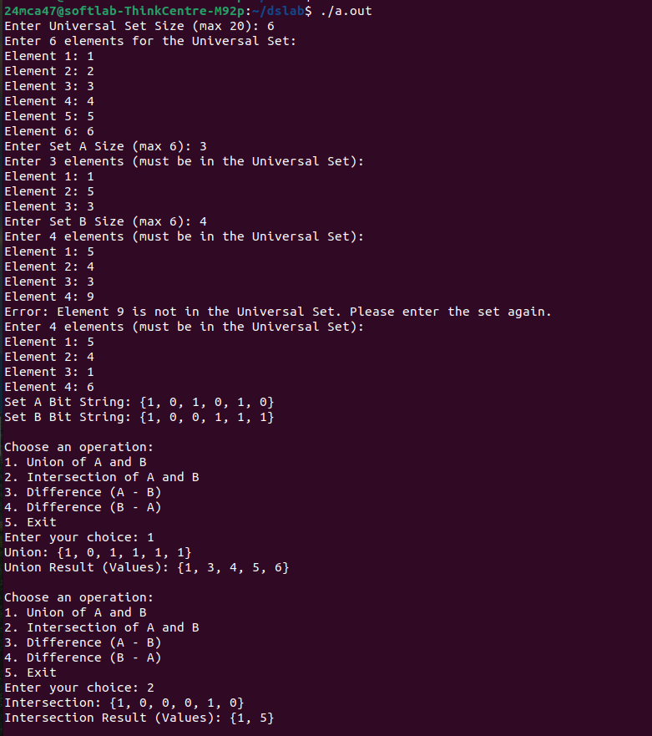

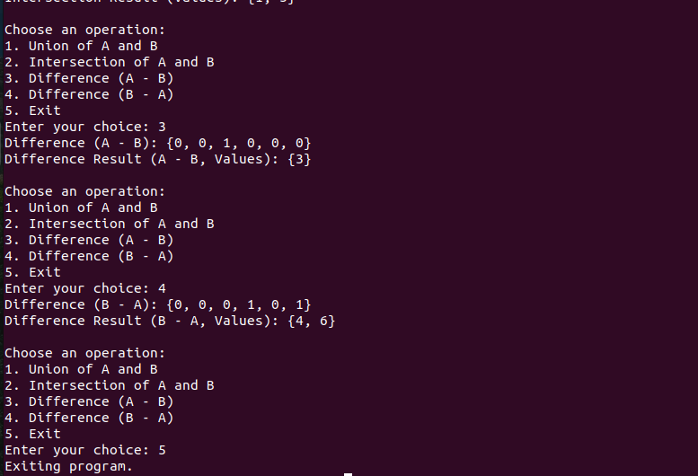

Program 7

Aim:
Program to implement disjoint set ADT with create union and find operations

Program code:

#include <stdio.h>
#include <stdlib.h>

struct node {
struct node *rep;
struct node *next;
int data;
} *heads[50], *tails[50];

static int countRoot = 0;

void makeSet(int x) {
struct node *new = (struct node *)malloc(sizeof(struct node));
new->rep = new;
new->next = NULL;
new->data = x;
heads[countRoot] = new;
tails[countRoot] = new;
countRoot++;
}

struct node* find(int a) {
int i;
struct node *tmp;
for (i = 0; i < countRoot; i++) {
tmp = heads[i];
while (tmp != NULL) {
if (tmp->data == a)
return tmp->rep;
tmp = tmp->next;
}
}
return NULL;
}
void unionSets(int a, int b) {
int i, j, pos, flag = 0;
struct node *tail2;
struct node *rep1 = find(a);
struct node *rep2 = find(b);
if (rep1 == NULL || rep2 == NULL) {
printf("\nElement(s) not present in the DS\n");
return;
}
if (rep1 != rep2) {
for (j = 0; j < countRoot; j++) {
if (heads[j] == rep2) {
pos = j;
flag = 1;
countRoot -= 1;
tail2 = tails[j];
for (i = pos; i < countRoot; i++) {
heads[i] = heads[i+1];
tails[i] = tails[i+1];
}
break;
}
}
for (j = 0; j < countRoot; j++) {
if (heads[j] == rep1) {
tails[j]->next = rep2;
tails[j] = tail2;
break;
}
}

while (rep2 != NULL) {
rep2->rep = rep1;
rep2 = rep2->next;
}
}
}
int search(int x) {
int i;
struct node *tmp;
for (i = 0; i < countRoot; i++) {
tmp = heads[i];
while (tmp != NULL) {
if (tmp->data == x)
return 1;
tmp = tmp->next;
}
}
return 0;
}

void displayRepresentatives() {
printf("\nSet Representatives: ");
for (int i = 0; i < countRoot; i++) {
printf("%d ", heads[i]->data);
}
printf("\n");
}

void displaySets() {
int i, j;
struct node *temp;
printf("\nDisjoint Sets:\n");
for (i = 0; i < countRoot; i++) {
temp = heads[i];
printf("{ ");
int first = 1;
while (temp != NULL) {
if (!first) printf(", ");
printf("%d", temp->data);
first = 0;
temp = temp->next;
}
printf(" }\n");
}
}
int main() {
int choice, x, y, setSize;
printf("Enter the size of the set (1 to 50): ");
scanf("%d", &setSize);

while (setSize <= 0 || setSize > 50) {
printf("Invalid set size. Please enter a size between 1 and 50: ");
scanf("%d", &setSize);
}

printf("\nEnter %d unique elements for the set:\n", setSize);
for (int i = 0; i < setSize; ) {
printf("Enter element %d: ", i + 1);
scanf("%d", &x);
if (search(x)) {
printf("Element %d already exists in the set. Please enter a unique element.\n", x);
} else {
makeSet(x);
i++;
}
}
do {
printf("\n1. Display set representatives");
printf("\n2. Union");
printf("\n3. Find Set");
printf("\n4. Display all sets");
printf("\n5. Exit");
printf("\nEnter your choice: ");
scanf("%d", &choice);

switch(choice) {
case 1:
displayRepresentatives();
break;
case 2:
printf("\nEnter first element: ");
scanf("%d", &x);
printf("Enter second element: ");
scanf("%d", &y);
unionSets(x, y);
break;
case 3:
printf("\nEnter the element to find: ");
scanf("%d", &x);
struct node *rep = find(x);
if (rep == NULL) {
printf("\nElement not present in the DS\n");
} else {
printf("\nThe representative of %d is %d\n", x, rep->data);
}
break;
case 4:
displaySets();
break;
case 5:
printf("\nExiting program...\n");
exit(0);
default:
printf("\nInvalid choice! Please try again.\n");
break;
}
} while (1);

return 0;
}

Output:

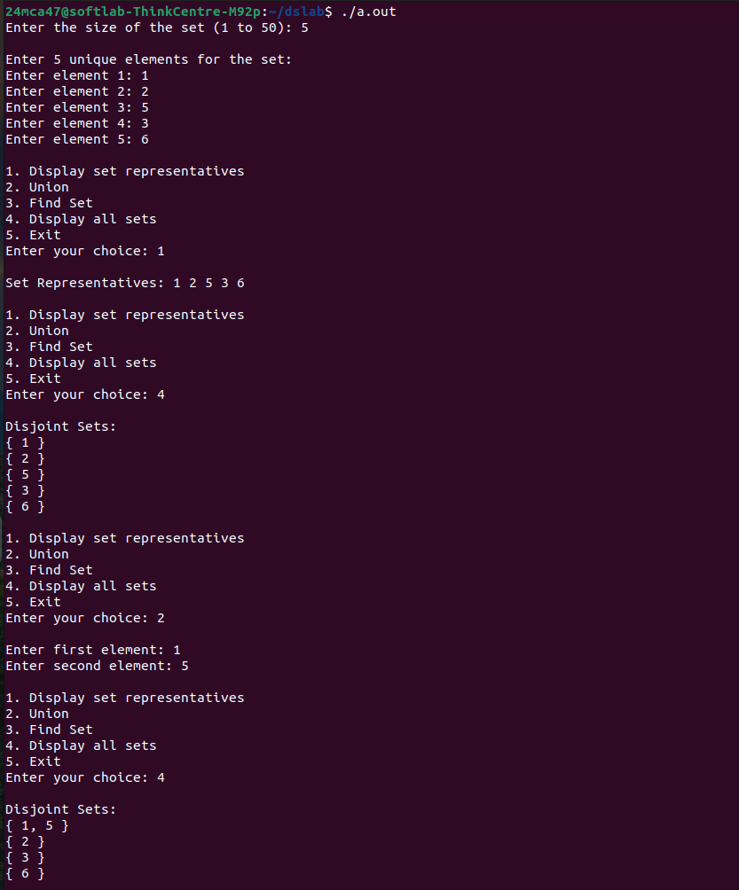

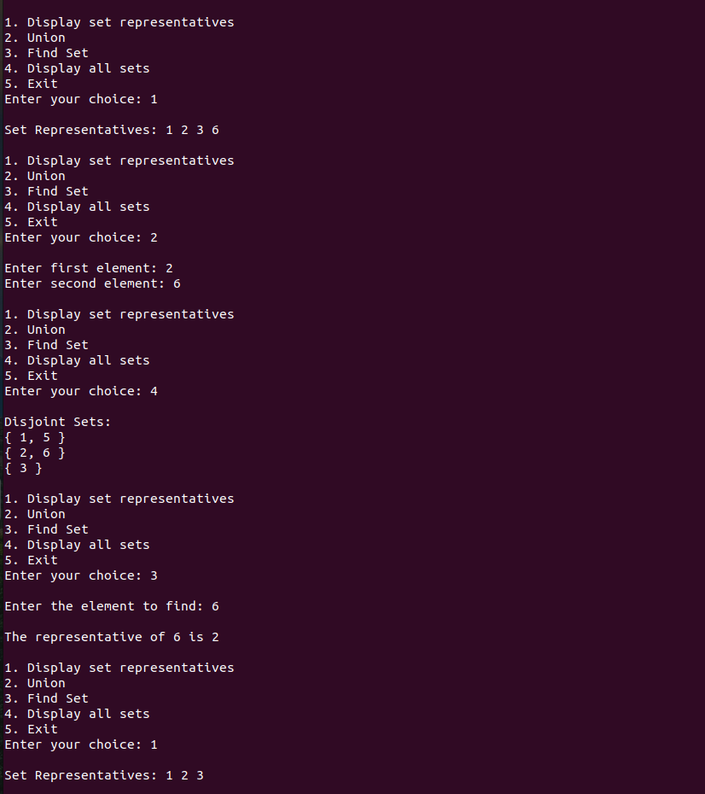

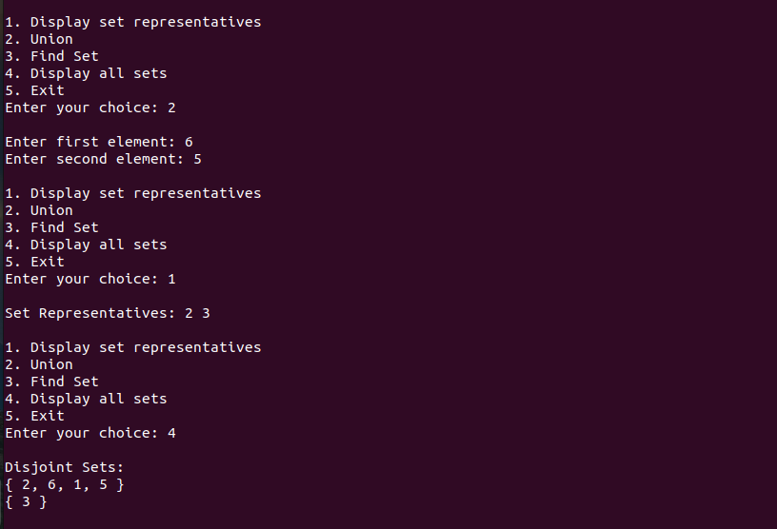

Program 8

Aim:
Graph Traversal techniques(dfs and bfs) and topological sorting

Program code:

#include <stdio.h>
#include <stdlib.h>
#include <stdbool.h>
#define MAX_VERTICES 10
int s;
struct Graph {
int numVertices;
int adjMatrix[MAX_VERTICES][MAX_VERTICES];
};

void initGraph(struct Graph* graph, int vertices) {
graph->numVertices = vertices;
for (int i = 0; i < vertices; i++) {
for (int j = 0; j < vertices; j++) {
graph->adjMatrix[i][j] = 0;
}
}
}

void addEdge(struct Graph* graph, int src, int dest) {
graph->adjMatrix[src][dest] = 1;
}

void DFSUtil(struct Graph* graph, int vertex, bool visited[]) {
visited[vertex] = true;
printf("%d ", vertex);

for (int i = 0; i < graph->numVertices; i++) {
if (graph->adjMatrix[vertex][i] == 1 && !visited[i]) {
DFSUtil(graph, i, visited);
}
}
}

void DFS(struct Graph* graph, int startVertex) {
bool visited[MAX_VERTICES] = { false };
printf("DFS starting from vertex %d: ", startVertex);
DFSUtil(graph, startVertex, visited);
for (int i = 0; i < graph->numVertices; i++) {
if (!visited[i]) {
DFSUtil(graph, i, visited);
}
}
printf("\n");
}

void BFS(struct Graph* graph, int startVertex) {
bool visited[MAX_VERTICES] = { false };
int queue[MAX_VERTICES];
int front = 0, rear = 0;

visited[startVertex] = true;
queue[rear++] = startVertex;

printf("BFS starting from vertex %d: ", startVertex);

while (front < rear) {
int currentVertex = queue[front++];
printf("%d ", currentVertex);

for (int i = 0; i < graph->numVertices; i++) {
if (graph->adjMatrix[currentVertex][i] == 1 && !visited[i]) {
visited[i] = true;
queue[rear++] = i;
}
}
}
printf("\n");
}

void topologicalSortUtil(struct Graph* graph, int vertex, bool visited[], bool recursionStack[], int stack[], int* stackIndex) {

if (recursionStack[vertex]) {
printf("The graph is not acyclic (contains a cycle).\n");
exit(0);
}

if (visited[vertex]) {
return;
}

visited[vertex] = true;
recursionStack[vertex] = true;

for (int i = 0; i < graph->numVertices; i++) {
if (graph->adjMatrix[vertex][i] == 1) {
topologicalSortUtil(graph, i, visited, recursionStack, stack, stackIndex);
}
}

recursionStack[vertex] = false;
stack[(*stackIndex)++] = vertex;
}

void topologicalSort(struct Graph* graph) {

bool visited[MAX_VERTICES] = { false };
bool recursionStack[MAX_VERTICES] = { false };
int stack[MAX_VERTICES];
int stackIndex = 0;

for (int i = 0; i < graph->numVertices; i++) {
if (!visited[i]) {
topologicalSortUtil(graph, i, visited, recursionStack, stack, &stackIndex);
}
}

printf("Topological Sort: ");
for (int i = stackIndex - 1; i >= 0; i--) {
printf("%d ", stack[i]);
}
printf("\n");
}

void displayAdjMatrix(struct Graph* graph) {
printf("\nGraph Representation (Adjacency Matrix):\n");
for (int i = 0; i < graph->numVertices; i++) {
for (int j = 0; j < graph->numVertices; j++) {
printf("%d ", graph->adjMatrix[i][j]);
}
printf("\n");
}
}

int main() {
struct Graph graph;
int vertices, edges, src, dest, startVertex, choice;
printf("Enter the number of vertices: ");
scanf("%d", &vertices);
initGraph(&graph, vertices);
printf("Enter the number of edges: ");
scanf("%d", &edges);
for (int i = 0; i < edges; i++) {
printf("Enter edge %d (eg:1 2): ", i + 1);
scanf("%d %d", &src, &dest);
if (src >= 0 && src < vertices && dest >= 0 && dest < vertices) {
addEdge(&graph, src, dest);
} else {
printf("Invalid edge! Please enter vertices within the range of 0 to %d.\n", vertices - 1);
i--;
}
}
do {
printf("\nMenu:\n");
printf("1. Display Adjacency Matrix\n");
printf("2. DFS Traversal\n");
printf("3. BFS Traversal\n");
printf("4. Topological Sort\n");
printf("5. Exit\n");
printf("Enter your choice: ");
scanf("%d", &choice);
switch (choice) {
case 1:
displayAdjMatrix(&graph);
break;
case 2:
printf("\nEnter the start vertex for DFS: ");
scanf("%d", &startVertex);
if (startVertex >= 0 && startVertex < vertices) {
DFS(&graph, startVertex);
} else {
printf("Invalid start vertex!\n");
}
break;
case 3:
printf("\nEnter the start vertex for BFS: ");
scanf("%d", &startVertex);
if (startVertex >= 0 && startVertex < vertices) {
BFS(&graph, startVertex);
} else {
printf("Invalid start vertex!\n");
}
break;
case 4:
topologicalSort(&graph);
break;
case 5:
printf("Exiting the program.\n");
break;
default:
printf("Invalid choice! Please try again.\n");
}
} while (choice != 5);
return 0;
}

Output:

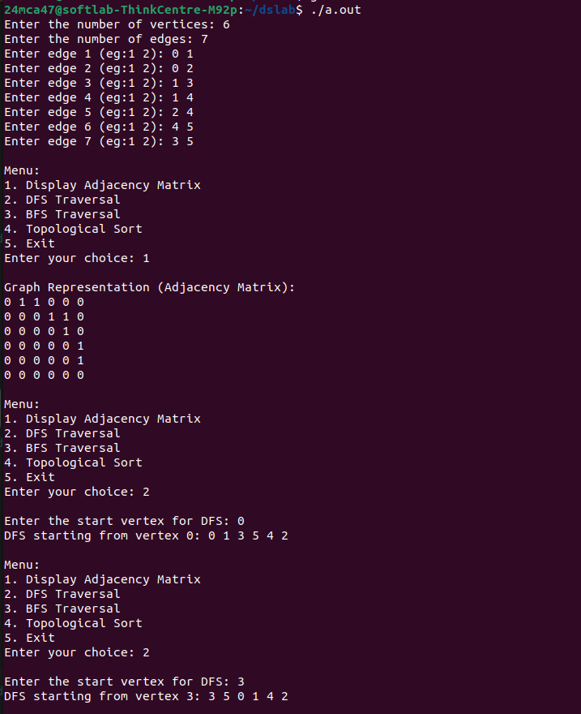

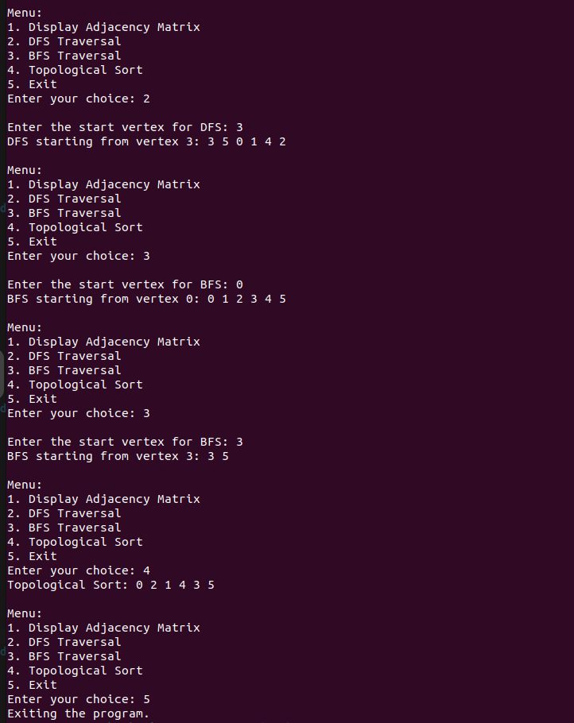

Program 9

Aim:
Find Strongly Connected components in directed graph

Program code:

#include <stdio.h>
#include <stdlib.h>
#include <stdbool.h>

#define MAX_VERTICES 10

// Adjacency list node
struct Node {
int vertex;
struct Node* next;
};

// Graph structure
struct Graph {
int numVertices;
struct Node* adjList[MAX_VERTICES];
struct Node* reverseAdjList[MAX_VERTICES];
};

// Function to create a new node
struct Node* createNode(int vertex) {
struct Node* newNode = (struct Node*)malloc(sizeof(struct Node));
newNode->vertex = vertex;
newNode->next = NULL;
return newNode;
}

// Function to initialize the graph
void initGraph(struct Graph* graph, int vertices) {
graph->numVertices = vertices;
for (int i = 0; i < vertices; i++) {
graph->adjList[i] = NULL;
graph->reverseAdjList[i] = NULL;
}
}

// Function to add an edge to the graph (Directed)
void addEdge(struct Graph* graph, int src, int dest) {
struct Node* newNode = createNode(dest);
newNode->next = graph->adjList[src];
graph->adjList[src] = newNode;

// Reverse edge for the reverse graph
newNode = createNode(src);
newNode->next = graph->reverseAdjList[dest];
graph->reverseAdjList[dest] = newNode;
}

// DFS (Depth First Search)
void DFS(struct Graph* graph, int vertex, bool visited[], int stack[], int* stackIndex) {
visited[vertex] = true;

struct Node* adjList = graph->adjList[vertex];
while (adjList != NULL) {
int adjVertex = adjList->vertex;
if (!visited[adjVertex]) {
DFS(graph, adjVertex, visited, stack, stackIndex);
}
adjList = adjList->next;
}

stack[*stackIndex] = vertex;
(*stackIndex)++;
}

// DFS on reversed graph
void DFSReverse(struct Graph* graph, int vertex, bool visited[], int* component) {
visited[vertex] = true;
component[vertex] = 1;

struct Node* adjList = graph->reverseAdjList[vertex];
while (adjList != NULL) {
int adjVertex = adjList->vertex;
if (!visited[adjVertex]) {
DFSReverse(graph, adjVertex, visited, component);
}
adjList = adjList->next;
}
}

// Function to perform Kosaraju's Algorithm to find SCCs
void kosarajuSCC(struct Graph* graph) {
bool visited[MAX_VERTICES] = { false };
int stack[MAX_VERTICES];
int stackIndex = 0;

// Step 1: Perform DFS on the original graph and fill the stack with the vertices in finishing time order
for (int i = 0; i < graph->numVertices; i++) {
if (!visited[i]) {
DFS(graph, i, visited, stack, &stackIndex);
}
}

// Step 2: Reverse the graph is already done in `addEdge` function

// Step 3: Perform DFS on the reversed graph, using the order in the stack
// We will output the SCCs here
for (int i = 0; i < graph->numVertices; i++) {
visited[i] = false;
}

printf("Strongly Connected Components (SCCs):\n");

while (stackIndex > 0) {
int vertex = stack[--stackIndex];
if (!visited[vertex]) {
int component[MAX_VERTICES] = { 0 }; // To track the SCC

// DFS on the reverse graph to get all nodes in this SCC
DFSReverse(graph, vertex, visited, component);

// Print the SCC
printf("{ ");
for (int i = 0; i < graph->numVertices; i++) {
if (component[i]) {
printf("%d ", i);
}
}
printf("}\n");
}
}
}

// Function to display the graph (adjacency list)
void displayGraph(struct Graph* graph) {
printf("\nGraph Representation (Adjacency List):\n");
for (int i = 0; i < graph->numVertices; i++) {
struct Node* adjList = graph->adjList[i];
printf("Vertex %d: ", i);
while (adjList != NULL) {
printf("%d -> ", adjList->vertex);
adjList = adjList->next;
}
printf("NULL\n");
}
}

int main() {
struct Graph graph;
int vertices, edges, src, dest, choice;

// Input number of vertices and edges
printf("Enter the number of vertices: ");
scanf("%d", &vertices);
initGraph(&graph, vertices);

// Input edges
printf("Enter the number of edges: ");
scanf("%d", &edges);

for (int i = 0; i < edges; i++) {
printf("Enter edge %d (source destination): ", i + 1);
scanf("%d %d", &src, &dest);

// Add directed edge to the graph
if (src >= 0 && src < vertices && dest >= 0 && dest < vertices) {
addEdge(&graph, src, dest);
} else {
printf("Invalid edge! Please enter vertices within the range of 0 to %d.\n", vertices - 1);
i--; // Decrement i to allow user to input the edge again
}
}

// Main menu
do {
printf("\nMenu:\n");
printf("1. Display Graph\n");
printf("2. Find Strongly Connected Components (SCCs)\n");
printf("3. Exit\n");
printf("Enter your choice: ");
scanf("%d", &choice);

switch (choice) {
case 1:
displayGraph(&graph);
break;
case 2:
kosarajuSCC(&graph);
break;
case 3:
printf("Exiting the program.\n");
break;
default:
printf("Invalid choice! Please try again.\n");
}
} while (choice != 3);

return 0;
}
Output:

